Eric Owens
I am writing for the purpose of self-nomination to serve as the 56th President of the Pennsylvania Counseling Association. It is an honor and privilege to be considered for the role. I hold a PhD in Counselor Education and Supervision from Duquesne University and have been a proud member of PCA since 2008. I have worked as a professional counselor in Pennsylvania for over 20 years and have been a full-time counselor educator at West Chester University since 2011. I am a Licensed Professional Counselor (PA), Nationally Certified Counselor, Approved Clinical Supervisor, and am certified as a Professional School Counselor (PA). Through these many experiences, I believe I can bring a wealth of knowledge and skill, both within PCA and in the field in general.
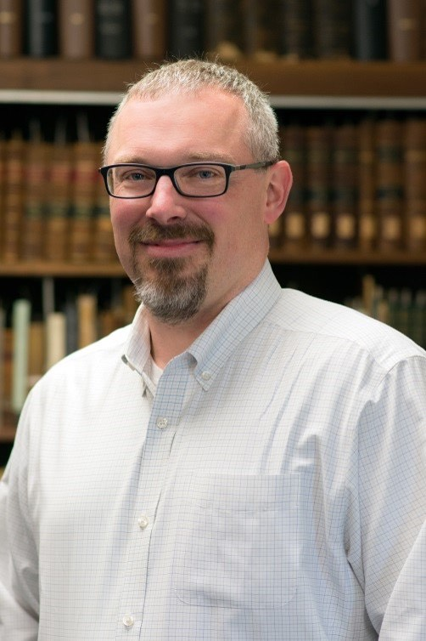
As a member of PCA, I have held several leadership positions within our organization. I served as Co-Chair of the Membership Committee from 2014-2016 and as the Associate Editor of the Journal of the Pennsylvania Counseling Association from 2014-2017. While serving on the Editorial Board I was able to work closely with Editor (and future PCA President) Dr. Joe Behun to bring the Journal to a greater level of prominence. Finally, I served as President of the Pennsylvania Association for Counselor Education and Supervision (PACES) from 2018-2020 and Past-President from 2020-2022. In these roles, I hope I was able to help my colleagues navigate the initial challenges of teaching through the COVID-19 pandemic.
As a Professor at West Chester University, I have the privilege of preparing the next generation of professional counselors. Our program was recognized as the PCA Counselor Education Program of the Year in 2016, an acknowledgement for which I am very proud. I have also served for the past six years as chairperson of our department, which has been extremely rewarding. While I have held many leadership positions, guiding an academic department has provided me with an excellent opportunity to further develop my skills as a servant leader. While I have chosen not to run for another term as chair, I do hope I can continue to use my leadership skills and further the efforts of PCA.
In addition to my role as a faculty member I also maintain a small private practice. I believe this allows me to stay grounded in the field, as well as continue to grow as a counselor and teacher. For example, providing therapeutic services through the pandemic has provided me with insight into the ongoing challenges of serving our clients. From the mental health pandemic that is upon us to the challenges of providing telehealth, my continued service as a counselor has allowed me to keep one foot firmly planted as a practitioner.
Through these opportunities, I have had the chance to see how PCA works and have worked with PCA leadership for many years. I have been lucky enough to see this organization grow and flourish over the past 13 years and I hope I can be part of continuing that legacy.

