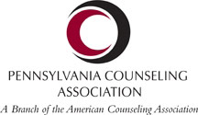GPACA_LOGO-CICLE-LOVE.pdf 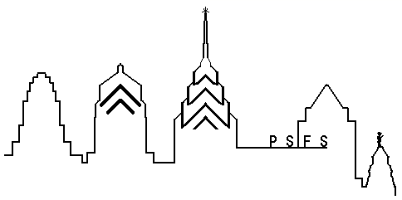

**3rd Annual**

**Counseling Career and Job Fair**

**Saturday, June 15th 🞟8:30 AM - 12:00 PM**

Bars **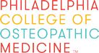** Philadelphia College of Osetopathic Medicine logo

***Hosted by:***

**Philadelphia College of Osteopathic Medicine’s *MS in Counseling Programs***

**4170 City Avenue**

**Philadelphia, PA 19131**

**Recreation Center**

Bars

**Looking for a job? Want to advance your career?**

**Wondering what to do with your Counseling degree?**

**Need Resume Advice?**

**Want to become involved in Counseling Organizations?**

**Presentations by seasoned professionals**

**Meet potential employers**

**Learn about a variety of agencies**

**Please RSVP: GPACAweb@gmail.com**

**This is a FREE EVENT**