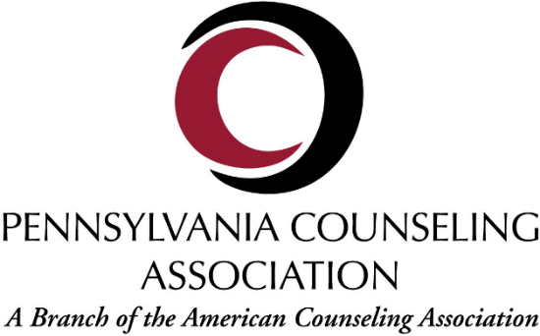
Conference Sponsorship and Exhibitor Application
Platinum Tier - $5000  (1 Opportunity) | Gold Tier - $2500  (2 Opportunities) | Silver Tier - $1000  (4 Opportunities) | Bronze Tier - $500
LANYARD SPONSOR, Whova App, Exhibitor Hall Table, Primary Space on banner on stage with primary presenters (e.g. at welcome, dinner, etc.), Email Blasts, Social Media Sponsorship, Bag Sponsor | Credit for drink tickets at either opening mixer or Saturday dinner, Whova App, Exhibitor Hall Table, Primary Space on banner on stage with primary presenters (e.g. at welcome, dinner, etc.), Email Blasts, Social Media Sponsorship, Bag Sponsor | Coffee Break Sponsor, Whova App, Secondary Space on banner on stage with primary presenters, Exhibitor Hall Table, Email blasts, Social Media Sponsor, Bag Sponsor | Whova App, Exhibitor Hall Table, Email blasts, Social Media Sponsor, Bag Sponsor
Check Here: | Check Here: | Check Here: | Check Here:
Description of Opportunities on the other side of this page

Individual Sponsorship Opportunities
Check your preferences

Social Media Sponsorship Only - $100 _____

Whova App Only - $100 _____

Email Blast Only - $100 _____

Exhibitor hall/table only - $ 75 _____

Secondary Banner Space on Main Stage - $100 _____

Total of all Sponsorship Opportunities Chosen: $______________

Organization Name:_________________________________

Organization Address:__________________________________________________

Organization Contact Person: ___________________________________________

Phone number: __________________ Email: _______________
Conference Forms and any questions may be emailed to: pcamarketingdirector@gmail.com
Sponsor Information and receipt will be emailed to the identified contact person
Payment: Checks made payable to PCA and sent to PCA Treasurer PO Box 444 Brookville, PA 15825.
For credit card payments initial here_____ and the PCA Treasurer will invoice you.
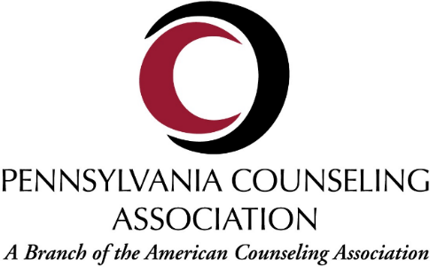
Explanation of Sponsorship Opportunities

Whova App Banner:
The Whova App is our central conference app. This helps all of our conference attendees see what lectures and events are open to them and interact with other attendees. Within the Whova App there are banners where your company’s name will appear when the app is open.

PCA Email Blast:
Your company’s name will be listed as a conference sponsor on email correspondence sent out to every PCA member including 3 specific sponsor emails that thank our gracious supporters.

Social Media Shout Outs:
We will blast your company’s name and logo across our social media platforms. We will post sponsors at minimum twice per week in the three months leading up to the conference, and then daily during the week leading up to the conference, with one final blast expressing our gratitude in the week following the conference.

Banner Credit:
Your company’s name will be showcased on the main stage behind the primary presenters at the central events (opening mixer, conference greeting, awards luncheon, closing lecture, etc.) attended by the majority of our conference attendees. This is an excellent way to for your company to be recognized front and center throughout the entire conference.

Lanyard Sponsor: *One Sponsor Opportunity Available, attached to “Platinum Tier” Sponsorship*
Your company’s name will be printed next to the PCA logo on the conference lanyards given out to every attendee. This is a fantastic way to ensure your sponsorship is noticed by every attendee at the conference.

Drink Ticket Credit: *Two opportunities, attached to “Gold Tier” Sponsorship*
Your company will be named as the sponsor of complimentary drink tickets that are offered to conference attendees at the opening mixer and/or during

Coffee Break Sponsor: *Four opportunities, attached to “Silver Tier” Sponsorship*
Your company’s information will be placed on either the morning (2 sponsors) or afternoon (2 sponsors) coffee bar which will be made available to all attendees.

Bag Sponsor:
Your company’s logo will be included among the other Tiered sponsors on our Convention Bag which will be provided to all attendees when they pick up their name badges.

Exhibitor Information

Exhibit Space:
The cost for an exhibitor table space is $75 and includes a six-foot skirted table, two chairs, __________. The floor plan will be shared with the exhibitors in ______ as part of the conference information which will be emailed to the identified contact person.

Exhibitor Registration:
Meeting packets will be emailed in ______ at which time companies may designate the personnel they will have attending at their exhibitor table. Each exhibit is limited to individuals, business firms, manufacturers and dealers who have contracted and paid for space. Exhibit personnel must be employees of the sponsoring company, or be contracted in an official capacity for the company.

Hotel Reservations:
The continuing education courses, meetings, and the exhibit area will be held at _________. If you wish to reserve rooms for your employees at the hotel, you may do so by contacting the hotel at:

However, you may also make any other accommodations at neighboring hotels at your preference.

Parking is offered at the hotel and neighboring lots on a first come first served basis. PCA is not able to schedule or reserve any parking spaces for attendees, exhibitors, or other related conference personnel.

Rules and Regulations

Conduct and Restrictions: Pennsylvania Counseling Association (PCA) reserves the right to restrict and/or terminate all exhibits which, because of sound, odor, food, drink or other objectionable features, interfere with the orderly procedure of the conference. PCA also reserves the right to prohibit any display or procedure which in its judgement runs counter to the general character of the meeting. Products being promoted that do not meet the ethical standards of the counseling profession will not be accepted for display.

Exhibitors may not host a function in conjunction with Pennsylvania Counseling Association’s Conference without the written consent of PCA.

The exhibitor shall, during the conference, use for exhibit, display or related purposes, only the space which has been contracted. No exhibitor will conduct a seminar or presentation in the ________ hotel area from November 8-10, 2019.

Improper conduct (as the term is construed by the PCA and/or our contracted hotel and conference center, to include but not be limited to the representation of a product or service without the purchase of exhibit space, or the presence of any person associated with a commercial endeavor within the exhibit area who is not affiliated with a paid-in-full exhibitor) will not be permitted and can result in the termination of the exhibitor’s ability to display at the conference now or in the future. In the event termination does occur the exhibitor shall not be entitled to any refund of amounts paid to PCA.

Companies sponsoring prize drawings in conjunction with the conference must prominently display any limitations on registering for or accepting the prize.

The rights and obligations set forth herein apply as well to the conduct of agents and employees of the exhibitor and any property used by such companies in the installation and operation of exhibits.

The decision of PCA as to what acts constitute a breach of the above conditions shall be final and any exhibitor shall be subject to eviction without refund if it is judged to be in violation of the aforementioned conditions.

Space: The exhibitor agrees that the exhibit will be confined to the area of the space contracted and that subletting or showing products other than those manufactured or represented by the exhibitor is strictly prohibited. The exhibitor also agrees not to display noisy electronic devices, sound equipment or other devices that interfere with other exhibits. The playing of live or recorded music in an exhibit space is prohibited.

Care of Space: The exhibitor agrees not to deface, injure, or mar any surface of the hotel or conference center or any of the furniture or fixtures contained therein and/or any of the property placed therein by the PCA. The exhibitor shall be liable to PCA and the hotel and conference center for any damage to the hotel or any of the furniture or fixtures contained therein or any of the property placed therein by PCA which shall occur by reason of the commissions or omissions of any exhibitor and/or its agents or employees. All materials used in an exhibit must conform to the requirements of the fire department.

Liability, Security and Insurance: All exhibits and respective contents are displayed at the exhibitor’s risk. The exhibit area is in a public space of the hotel and conference center and will not be secure when the exhibit hours conclude. PCA assumes no responsibility for the personal property of their officers, agents, or employees. The exhibitor assumes entire responsibility and hereby agrees to protect, indemnify, defend and save harmless PCA, the contracted hotel and convention center, its owner and operator and their affiliated and subsidiary companies and their respective partners, directors, officers and employees and agents (the “indemnities”) against all claims, losses or damages to persons or property, governmental charges or fines and attorney’s fees arising out or caused by the exhibition’s installation, removal, maintenance or occupancy or use of the exhibition premises or part thereof, excluding only any liability caused by the sole negligence of the indemnities.
In addition, the exhibitor acknowledges that PCA, the hotel and conference center, and any of the other indemnities do not maintain insurance covering the exhibitor’s property and that it is the sole responsibility of the exhibitor to maintain insurance.

Payment: Contracts must be accompanied by payment in full or paid upon receipt of a credit card invoice. If any remaining balance of the full remittance of the contract has not been received by PCA by the Cancellation date of October 19, 2019 PCA reserves the right to cancel this contract without liability. In such an event, PCA shall retain the amount paid by the exhibitor as a forfeited deposit. Any exhibitor with a remaining balance by the start of the conference November 8, 2019, will not be allowed to set up until full payment has been remitted in the form of cash, certified check or money order.

Interpretations of Above Rules and Regulations: Above stated conditions are considered a part of this contract. PCA reserves the right to interpret them as well as make decisions on all points the rules and regulations do not cover. Decisions of the Pennsylvania Counseling Association are final.

