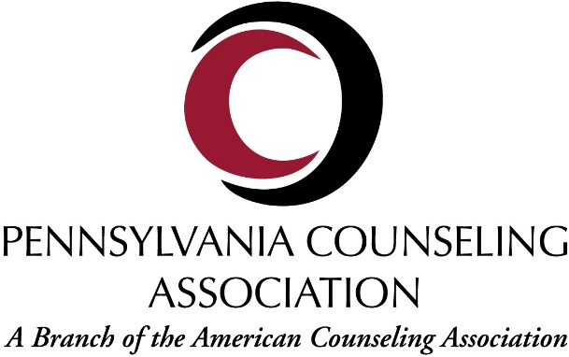
Professional Counselor Advocacy and our Promotion of Senate Bill 530
SB 530
SB 530 is a proposed basic practice protection that ensures individuals providing professional counseling services are regulated by the government. This means that professional counselors either work for a regulated entity or are a licensed provider and therefore are regulated by the Pennsylvania Department of State. In the best interest of protecting our clients, practice protection will guarantee a minimum level of education, skill, and responsibility for those who practice professional counseling in Pennsylvania.
What SB 530 means for Professional Counselors and their Clients in PA:
- Practice protection will ensure that only licensed professional counselors (LPC) practice counseling independently in Pennsylvania. This government oversight protects clients from under-qualified or potentially harmful providers and places a counseling supervision requirement on all practitioners.
- SB 530 will add "diagnosis" to the scope of practice for licensed professional counselors, further strengthening our professional identity.
- The State Board of Social Workers, Marriage and Family Therapists, and Professional Counselors is the only regulated board that does not have legal practice protection in place. SB 530 will provide our clients with the same level of protection as other licensed professions in Pennsylvania.
- Practice protection would reinforce professional counselors’ accountability to our profession and ensure that our clients are receiving the highest standard of care possible.
- At this point in time, anyone can legally provide independent counseling services in PA, regardless of licensure. Without practice protection, an individual who loses her/his license in another state may come to PA and practice without a license.
- Nationally recognized counseling credentials should always continue to be acknowledged and the usage of such credentials is encouraged. Master’s level practitioners who are graduates of counseling programs should continue to use the nationally valued title of Professional Counselor (PC).

